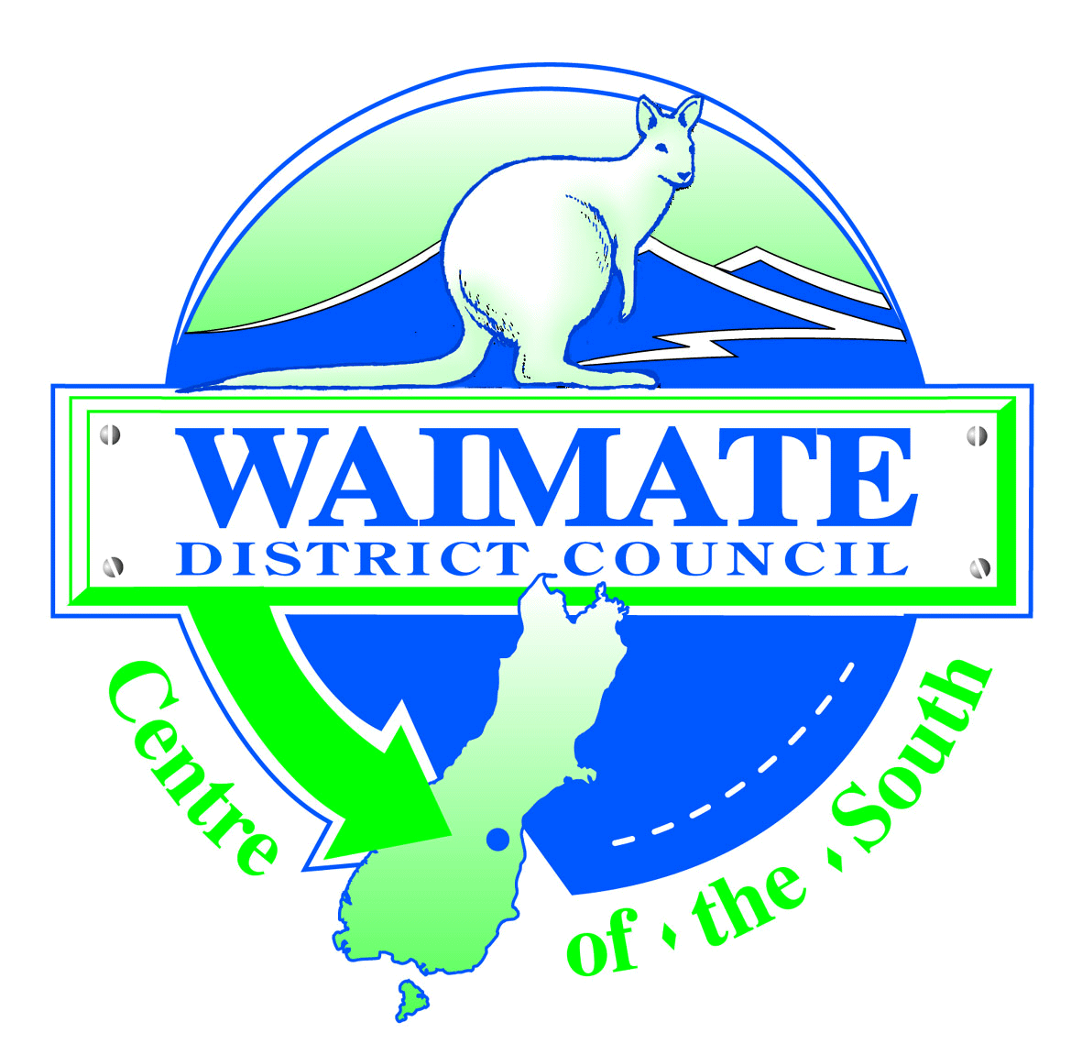 | Land Information Memorandum (LIM)  Application Request Form  Return Completed Application to:  125 Queen Street  PO Box 122 Telephone 03 689 0000  Waimate 7960 Fax 03 689 8075  Email: Council@Waimatedc.govt.nz

Issued in accordance with Section 44A of the Local Government Official Information and Meetings Act 1987

Applicant Details | Property Details
Name:  Address:  Attention:  Telephone:  Fax:  Email:  Signed:  Date: | Current Owner:  Property Location:  Valuation Reference:  Legal Description (Include copy of title if available):

Specific additional request about property:

LIM Fee and Type (PLEASE TICK)
⃝ Residential $350.00* including GST (Residential and/or Rural Properties less than 2.5 hectares)
⃝ Non-residential $500.00* including GST (Commercial, Industrial, Rural and/or Property over 2.5 hectares)
*For period commencing 1 July 2020 expiring 30 June 2021 dates inclusive

Please Note:
- It is the applicant’s responsibility to accurately identify the property.
- Council is unable to process this application unless ALL details requested are provided and fees payable accompany this application.
- A LIM will be issued within 10 working days of a full and complete application being received by Council.
- A separate application is required for each portion of land held under separate valuation references.
- Further Information overleaf.

Office Use Only
Application No:
Date Received:
Date Issued:
Receipt No:
Invoice No:
Debtor No:

Further Information

- Information provided is based on what is known to Council and what is shown in Council records which may not be complete. Every care will be taken to ensure that the information is correct, however, Council cannot guarantee that the information is accurate and does not accept any liability for errors in its records or errors in the presentation of information for these records.
- Council does not undertake any site inspection as part of the processing of this LIM.
- Council does not provide an interpretation of the information it discloses nor advice on how to interpret or utilise this information. Applicants should take their own independent and appropriate professional advice.
- If you have specific proposals for developing the property (e.g. building a new garage) or changing the use of the property, it is recommended that these be identified in request or discussed with Council prior to the purchase of the property.
- Conditions of any authorised uses of the land are contained in the relevant District and Regional Plans. If necessary, you should refer to relevant rules in these plans.
- Environment Canterbury Regional Council (Ecan) may also have information regarding this property. We recommend that you consider applying for a Land Information Request from Ecan at the same time you are applying for your LIM from Waimate District Council. Ecan can be contacted for a Land Information Request at ecinfo@ecan.govt.nz or telephone 0800 324 636 or apply online at www.ecan.govt.nz under Services, Online Services, Property Information. A charge will apply.

